|  |
| --- |
| **Team ID :** LTVIP2025TMID54810 |
| **Project Name :** ShopSmart: Your Digital Grocery Store Experience |

**Project Structure**

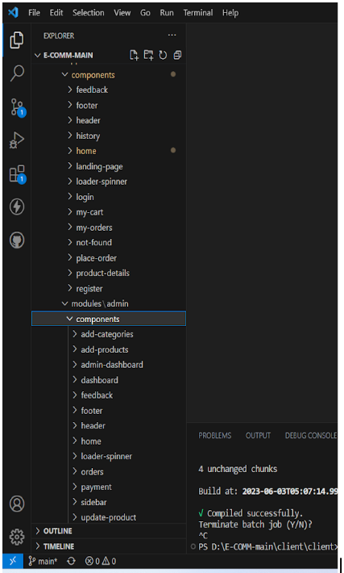

This structure assumes an Angular app and follows a modular approach. Here's a brief explanation of the main directories and files:

* src/app/components: Contains components related to the customer app, such as register, login, home, products, my-cart, my-orders, placeorder, history, feedback, product-details, and more.
* src/app/modules: Contains modules for different sections of the app. In this case, the admin module is included with its own set of components like add-category, add-product, dashboard, feedback, home, orders, payment, update-product, users, and more.
* src/app/app-routing.module.ts: Defines the routing configuration for the app, specifying which components should be loaded for each route.
* src/app/app.component.ts, src/app/app.component.html, `src.